Whitewater Rafting Site Plan

# Purpose

To create an immersive and user-friendly online platform and provide safe, thrilling, and unforgettable white-water rafting experiences that connect people with nature, promote outdoor adventure, and foster teamwork, personal growth, and environmental appreciation.

## Goals

* **Increase Online Visibility:** Establish a strong web presence to attract new customers and increase brand awareness.
* **Showcase Adventures:** Highlight the excitement and beauty of whitewater rafting through engaging visuals, videos, and testimonials.
* **Provide Essential Information:** Offer clear and concise details on trips, pricing, safety guidelines, and company policies.
* **Enhance User Experience:** Ensure the website is fast, mobile-friendly, and easy to navigate to keep visitors engaged and reduce bounce rates.
* **Expand Reach Through Partnerships:** Collaborate with travel agencies, outdoor brands, local tourism boards, and influencers to broaden your audience.
* **Offer Customization:** Provide flexible booking options and customizable adventure packages to cater to different groups (families, schools, corporate teams, thrill-seekers).
* **Gather Customer Insights:** Use analytics and feedback tools to understand customer behavior and continuously improve your services and offerings.

# Target Audience

* + **Demographics**: Adventure-seekers, outdoor enthusiasts, and nature lovers
  + **Psychographics**: Individuals seeking excitement, challenge, and connection with nature
  + **User personas**: First-time rafters, experienced rafters, families, and corporate groups

## Scenarios

The website should answer the following scenario questions:

* + Information on trip levels and difficulty
  + Detailed descriptions of what to expect during the trip
  + Testimonials and reviews from previous customers
  + Information on family-friendly trips and age restrictions
  + Details on safety measures and equipment provided
  + Options for booking a private guide or group trip
  + Recommendations for nearby activities and attractions for non-rafters
  + High-quality photos and videos showcasing the trip
  + Options for customizing the trip (e.g., private guides, camping)

# Site Map

Home

Contact Us

About Us

Trips

Branding

## Logo

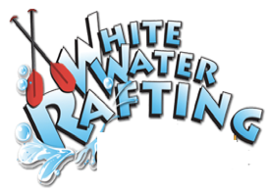

**Style Guide**

## Color Schema

Color palette URL: ***https://coolors.co/467291-625d36-249f99-6cb46c***

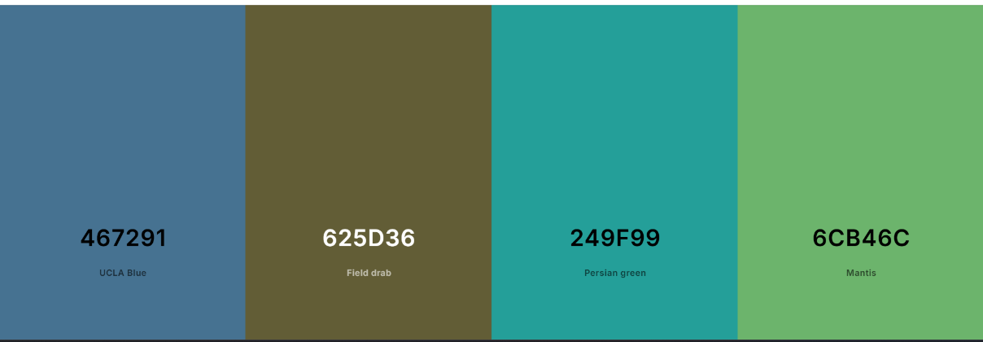

**Primary**

**Secondary**

**Accent 1**

**Accent 2**

## Typography

**Headings**: **Montserrat 400, 700, and Black**

**Body**: Libertinus Sans 400 and 700